Inter Patrol Quiz:

- Which animal is on the Welsh Flag?
- Which country has a Maple leaf on its Flag?
- The Jamaican Flag is made up of Green & Gold and which other colour?
- Which Country’s flag is not a rectangle or a square?
- Which Mediterranean island’s flag depicts the Geographical outline of the country?
- Does the Flag of Greenland have any ‘Green colour’ in it?
- How many horizontal stripes does the flag of Mauritius have?
- What shape is in the middle of the Vietnam Flag?
- Which colour is in the Union Jack, but not in the flag of England?
- The Flag of Estonia is made up of white & black and which other colour?

11

Located in West Africa
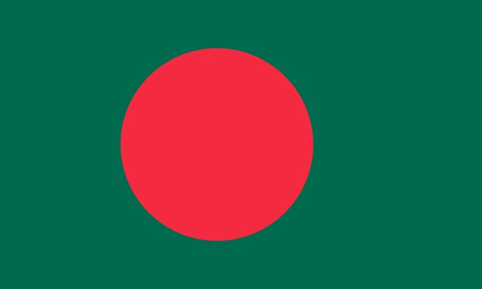 | 12  Floods Annually
13

European Skiing, but not in the Alps
14

(same Latitude as Q15)
15

(same Latitude as Q14)
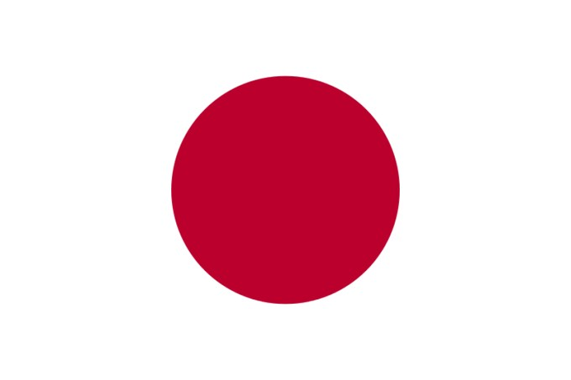 | 16  Land of the Rising Sun
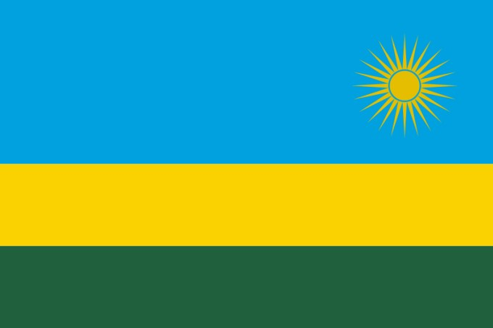 | 17  Country of genocide in 1990’s, now sponsor holidays on Arsenal’s football kit.
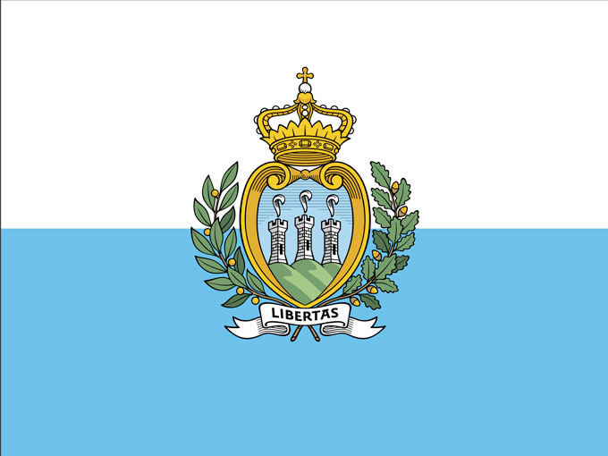 | 18  Worst Professional Football nation in Europe.
19

Fly-fishing Film
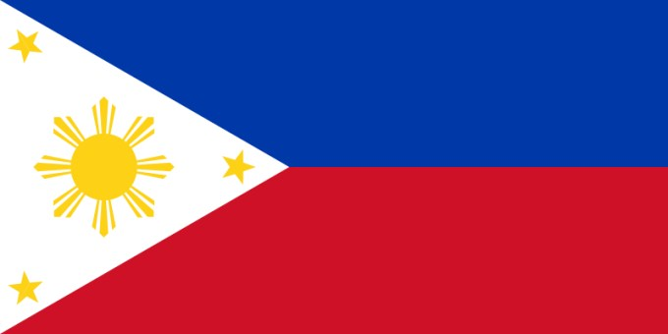  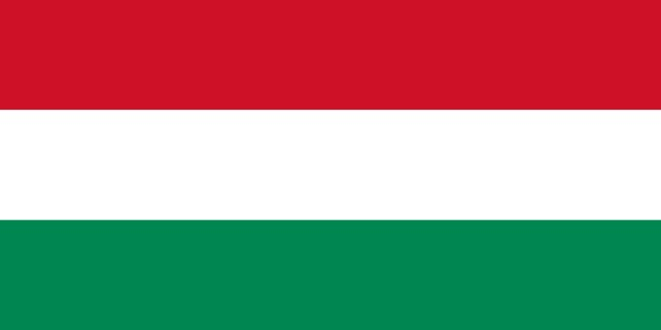 | 20  Manilla is the capital  21  Yum
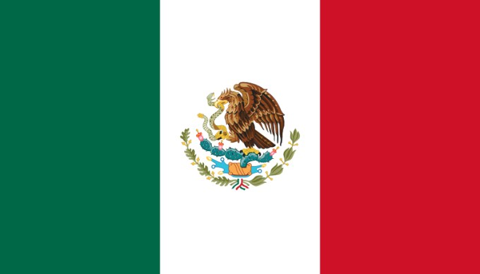 | 22  Paying for a wall?
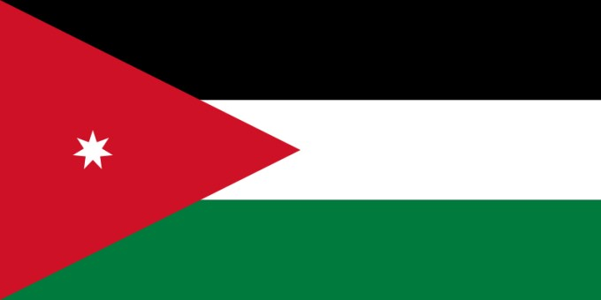 | 23  Katie Price?
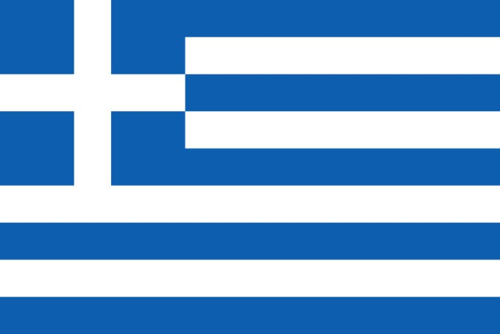 | 24  …lightening
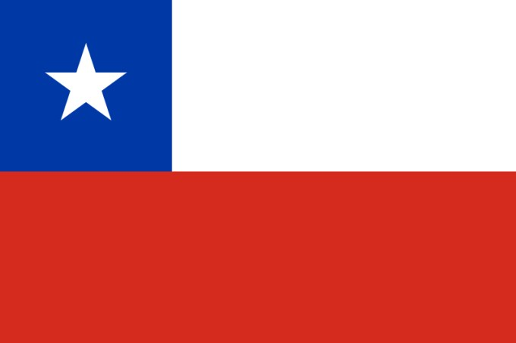 | 25  Hot & Cold
26 Tie break question:

Add the total number of stars on the American flag to the total number of stripes =……………

