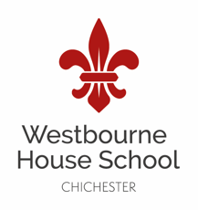 | Westbourne House School  Revision – Easter Term

Y7 HISTORY REVISION CHECKLIST

The Exams will consist of one paper with three sections:
- Knowledge and Understanding – this is what we have been learning about in our history lessons.
- Using sources to answer questions.
- Considering historians interpretations.
- The exam is largely based on the skills of history; however, pupils will need to be prepared to use the knowledge that they have acquired over the first term.
  - The three contenders for the throne in 1066
  - The events of 1066 (an outline)
  - How William kept control including the Feudal system
  - Castle building and improvements
  - Castle life and defences
  - Medieval villages
- In order to prepare for the exam, we will learn about the best revision techniques to use for revising history in our lessons after Christmas. There is no need to revise during the Christmas holidays.
Equipment you will need for the exam:
- Fountain pen and spare cartridges
- Pencil (Eraser/Sharpener)
- Ruler
- Highlighter

NOTES/TIPS:
For any further information or guidance about revision or the actual exam, please contact the Head of History – Mrs Armitage (barmitage@westbournehouse.org).

